1. Carrier Delay

1. NAS Delay

1. Weather Delay

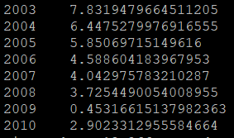

1. Late Aircraft Delay

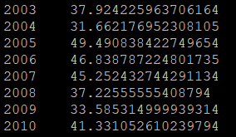

1. Security Delay

